HackerRank Program 5
Link :- https://www.hackerrank.com/challenges/fizzbuzz/problem

Successful Submission
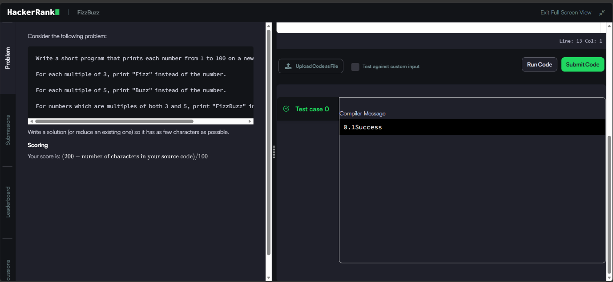
Source Code


